*Biology B Test : Meiosis, Mitosis*

**DO NOT WRITE ON TEST**

Figure 10-1

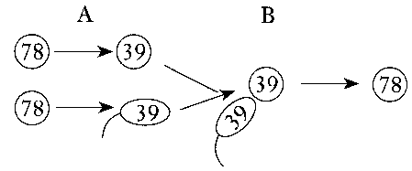

1. The numbers in Figure 10-1 represent the chromosome number found in each of the cells shown. The processes that are occurring at A and B are ____.

A. mitosis and fertilization B. mitosis and pollination

C. meiosis and fertilization D. meiosis and pollination

2. Segment of DNA on a chromosome; code for a specific trait.

A. Gene B. chromosome

C. genome D. nucleotide

3. The uniting of gametes is called:

A. Meiosis

B. Fertilization

C. Gametogenesis

4. Crossing over would most likely occur during which stage of the cell cycle?

A. when DNA is being replicated

B. when homologous chromosomes line up in pairs

C. when centromeres are separated

D. when cytokinesis begins

5. The typical human body cell contains 46 chromosomes. How many chromosomes are found in a typical human sperm or egg?

A.23

B. 45

C.46

D. 92

6. Which of the following is NOT true of meiosis?

A. Makes New Haploid Cells

B. Provides genetic variation through crossing over

C. Makes new diploid cells

7. A gamete has one-half the number of chromosomes of a regular body cell.

A. True B. False

8.Meiosis creates four identical cells.

A. True B. False

9. Which is the best description of the events that take place during anaphase II?

A. The replicated chromosomes become visible.

B. Homologous chromosomes line up along the equator.

C. Sister chromatids are separated and pulled to opposite sides of the cell.

D. Homologous pairs are separated and pulled to opposite sides of the cell.

Use the scenario below to answer the following questions.

A cell has 50 chromosomes. It goes through mitosis.

10. How many new daughter cells are created?

A. 1

B. 2

C. 3

D. 4

11. How many chromosomes are in each cell?

A. 50

B. 25

C. 30

D. 0

12. Are the cells identical?

A. Yes B. No

13. What process does the figure below show?

A. Crossing-over B. Mitosis

C. Meiosis D. Replication of DNA

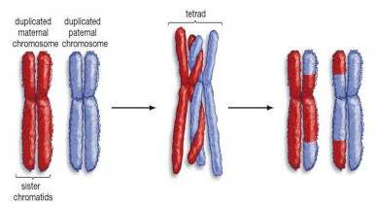

14. Which statement best explains the significance of meiosis in helping to maintain continuation of a species?

A. Meiosis produces eggs and sperm that are alike.

B. Meiosis provides for chromosomal variation in the gametes produced by an organism.

C. Equal numbers of eggs and sperm are produced by meiosis.

D. The gametes produced by meiosis ensure the continuation of any particular species by asexual reproduction.

15. Consider the cell labeled X in **Figure 10-9** containing 4 chromosomes. Which of the four cells below it represents a healthy gamete that could be produced from this cell?

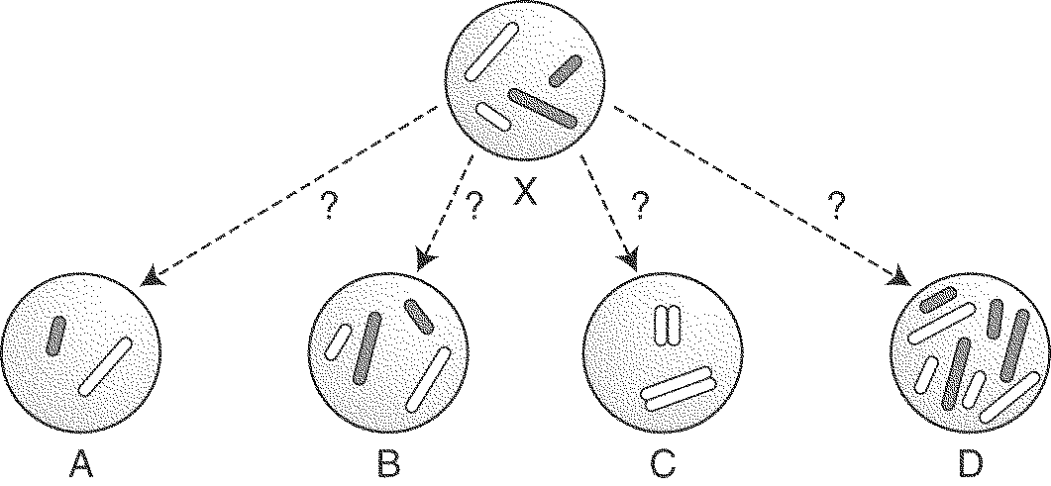

**Figure 10-9**

16. Which diagram represents the process of sperm formation in an organism that has a diploid chromosome number of eight?

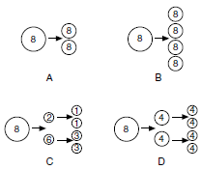

17. A benefit of sexual reproduction includes:

A. It is faster

B. Genetic variation

C. Less mutations

D. No need to find a mate

18. Newly created cells start the cell cycle in:

A. anaphase

B. interphase

C. metaphase

D. prophase

19. The four phases of mitosis, in the correct order, are:

A. anaphase, telophase, metaphase, and prophase

B. prophase, anaphase, telophase, and metaphase.

C. metaphase, anaphase, prophase, telophase

D. prophase, metaphase, anaphase, telophase

20. The only time in the cell cycle that the cell makes DNA is during:

A. prophase

B. S phase

C. G2 phase

D. Anaphase

21. Humans have 46 chromosomes in each cell, how many chromosomes will each daughter have after mitosis?

A. 46

B. 23

C. 20

D. 92

22. Cytokinesis refers to the division of the:

A. nucleus

B. chloroplasts

C. mitochondria

D. cytoplasm

**Matching:** *On the space provided on the answer sheet, write the letter of the choice on the right that best describes what happens in each phase of mitosis on the left.*

A. metaphase B. telophase C. prophase D. anaphase

22. A nuclear membrane forms around each set of chromosomes and cytokinesis begins.

23. The chromosomes line up in the middle of the cell and attach to the spindle fibers.

24. The sister chromatids are pulled away from each other by the spindle fibers.

25. The nuclear membrane disappears and chromosomes coil up.

26. Cells spend most of their time in this phase of the cell cycle.

A. Interphase B. Mitosis C. Cytokinesis

27. The part of interphase when the cell grows is called

A. prophase

B. S phase

C. G1 phase

D. G2 phase